L1 Identix 4100 Livescan Driver Installation Instructions for Windows 10 Operating System
*Administrator access to the computer is required when installing the driver.
L1 Identix 4100 Driver Installation Instructions using Google Chrome Browser

- Click on “L1 Identix 4100 Driver for Windows 10” at https://fadv.com/solutions/fingerprint-background-checks/livescan/
- After TP-LSMULTI-SDK64. Zip is downloaded select the up arrow and select Show in Folder.

- Double click TP-LSMULTI-SDK64-7-11.zip
- Right click "TP-LSMULTI-SDK64-7.11" and select Extract here, and then select Unzip.
- Double click TP-LSMULTI-SDK64-7.11 and then double click setup.exe or L-1 Identity Solutions TP-LSMULTI SDK (x64).msi.
- Select Yes at the User Account Control prompt.
- Select Next.
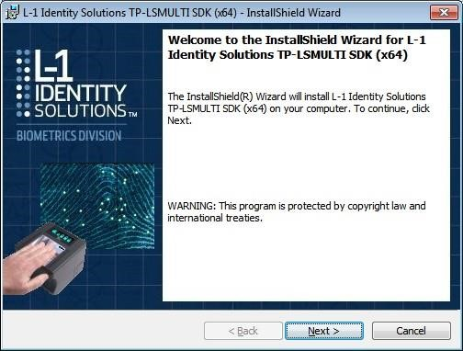

- Select I accept..., then click Next
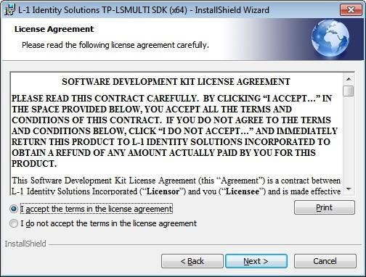
- The User Name and Organization are optional. Select Next.
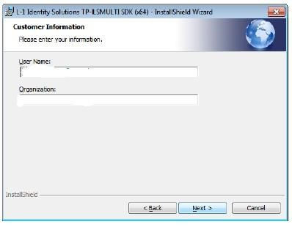

- Select 32-bit binaries. (If 64 bit is selected the scanner will not work)
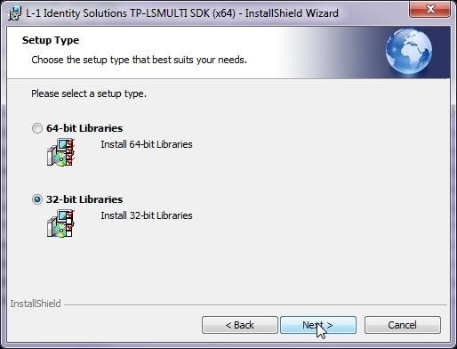
- Click Install.
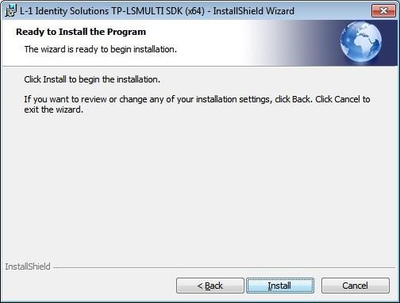

- Installation begins.
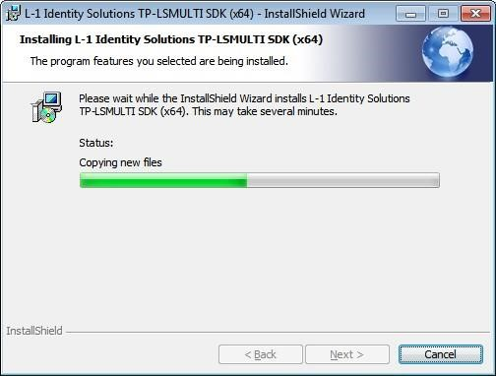
- Select Finish.
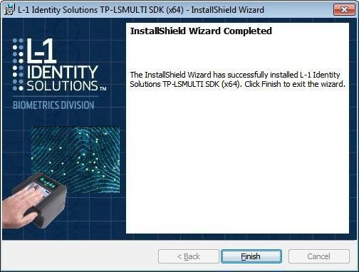
- Plug the scanner into a USB port on the computer and restart the computer.

Install the First Advantage – Scanning Component
- Click on “Fingerprint Advantage – Scanning Component at https://fadv.com/solutions/fingerprint-background-checks/livescan/
- After aware-biocomponent.zip is downloaded select the up arrow and select Open.

- Double click aware-biocomponents-fadv exe.
- If you get this message, select Yes.
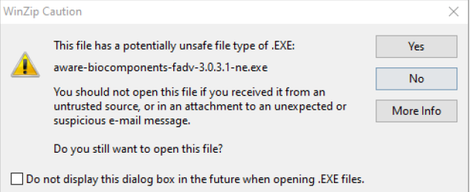
- Select Next
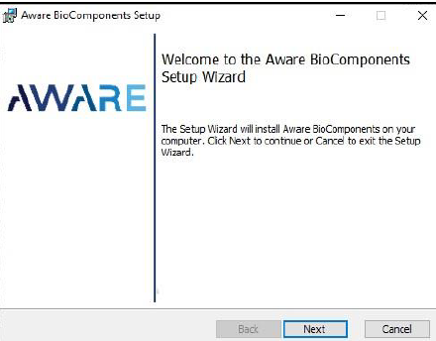
- Check “I accept the terms in the License Agreement” and then select Next.
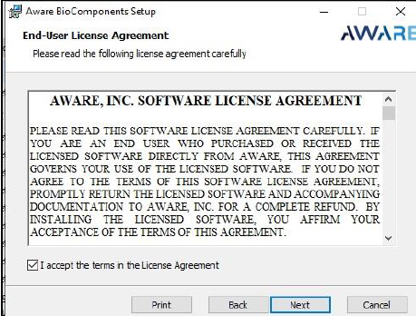
- Select Next.
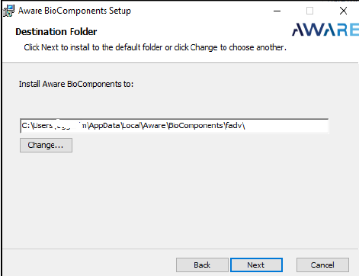
- Click “Finish” to complete the installation.
